Caitlyn Jones
Prof. Yangyang Wang
MATH 40A: Intro to Applied Math
25 November 2024
Homework 5

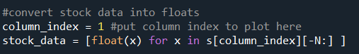
  - To plot the data of the opening price, I input that the column_index = 1in the given code.

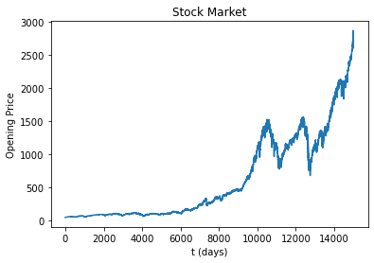
Here is the resulting graph.

  - Then, I made a semi-log plot. To do so, I used plt.semilogy and the function S(t) in order to prove that the data fits to a straight line.
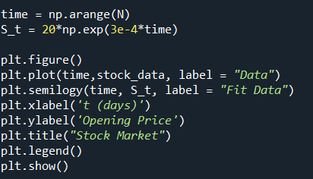

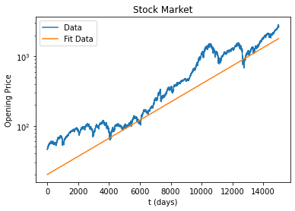
And here at the results, which show that the data fits to the straight line.

  - First, I created a list to store the opening prices of the data.

Then, I calculated the daily differences and made a histogram to show the distribution.

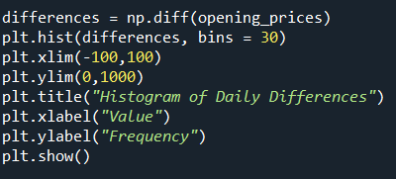

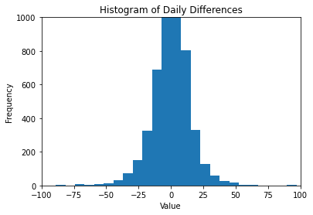
As you can see, the highest frequency of the difference in days was around zero. Since the frequency at zero keeps increasing, I changed the limits of the x and y axes in order to better see the outliers in the data. As you can see, there are a few differences that are rather large, which we can predict from the steep changes in opening prices from the graph in question 1.
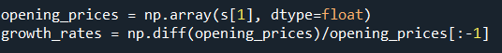
  - Next, I calculated the rate at which the stock prices grow.

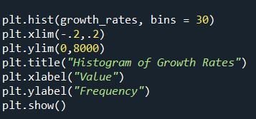
Then I made a histogram to display this difference.

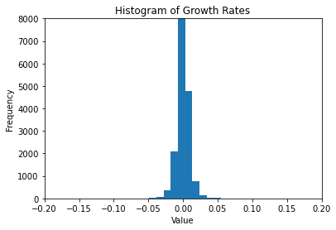

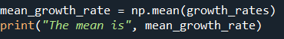
Lastly, I calculated the mean.



This means that on average, the stocks grow about .03% per day.
  - First, I changed the scale of the vertical y axis to be log to get the following graphs derived from part (a) and (b).
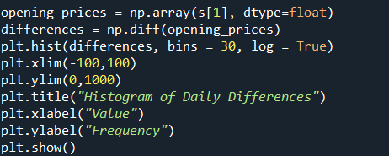

Is this a good fit?

